Technical Note
DHIS2 Aggregated Data Exchange Utility

Nepal Bikram Samvat (BS) Calendar to Gregorian AD Calendar

DHIS2 Climate and Health Project

1. Purpose of the Utility 2
2. Utility Design and Workflow 3
3. Workflow Description 5
3.1 Job Scheduling and Triggering 5
3.2 Workflow Initialization 5
3.3 Data Extraction from iHMIS DHIS2 5
3.4 Calendar Transformation (Nepali to Gregorian) 5
3.6 Data Submission to Nepal Climate DHIS2 6
3.7 Logging, Confirmation, and Notification 6
3.8 Workflow Completion 6

1. Purpose of the Utility

This utility is a Python-based scheduled data exchange tool designed to extract aggregated Dengue data from a source DHIS2 instance (Nepal HMIS), transform the data across calendar systems (Nepali BS to Gregorian AD), and push the aggregated monthly data into a target DHIS2 instance (Nepal Climate Health Instance). The utility runs automatically using a cron job and logs execution details for audit and troubleshooting.

2. Utility Design and Workflow

The high-level design of the utility is given below, along with key files available in the utility:
README.md:
Provides deployment, environment setup, dependency installation, and cron scheduling instructions.

pythonAggregatedDataValue.sh:
Shell wrapper used by cron to execute the Python script using the correct virtual environment.

constants.py:
Defines global constants such as timestamp-based log file names.

utils.py:
Implements logging, DHIS2 analytics data retrieval, Nepali-to-Gregorian calendar conversion, data transformation, DHIS2 dataValueSet posting, and optional email notification.

main.py:
Acts as the orchestration layer, determining reporting periods, invoking data extraction, transforming payloads, and pushing data to the target DHIS2 instance.

The utility calculates the previous Nepali month, fetches aggregated Dengue data via the DHIS2 Analytics API, converts the period to ISO format, constructs dataValueSet payloads, and posts them to the target DHIS2 instance. The key processes and workflows are defined below in the diagram.
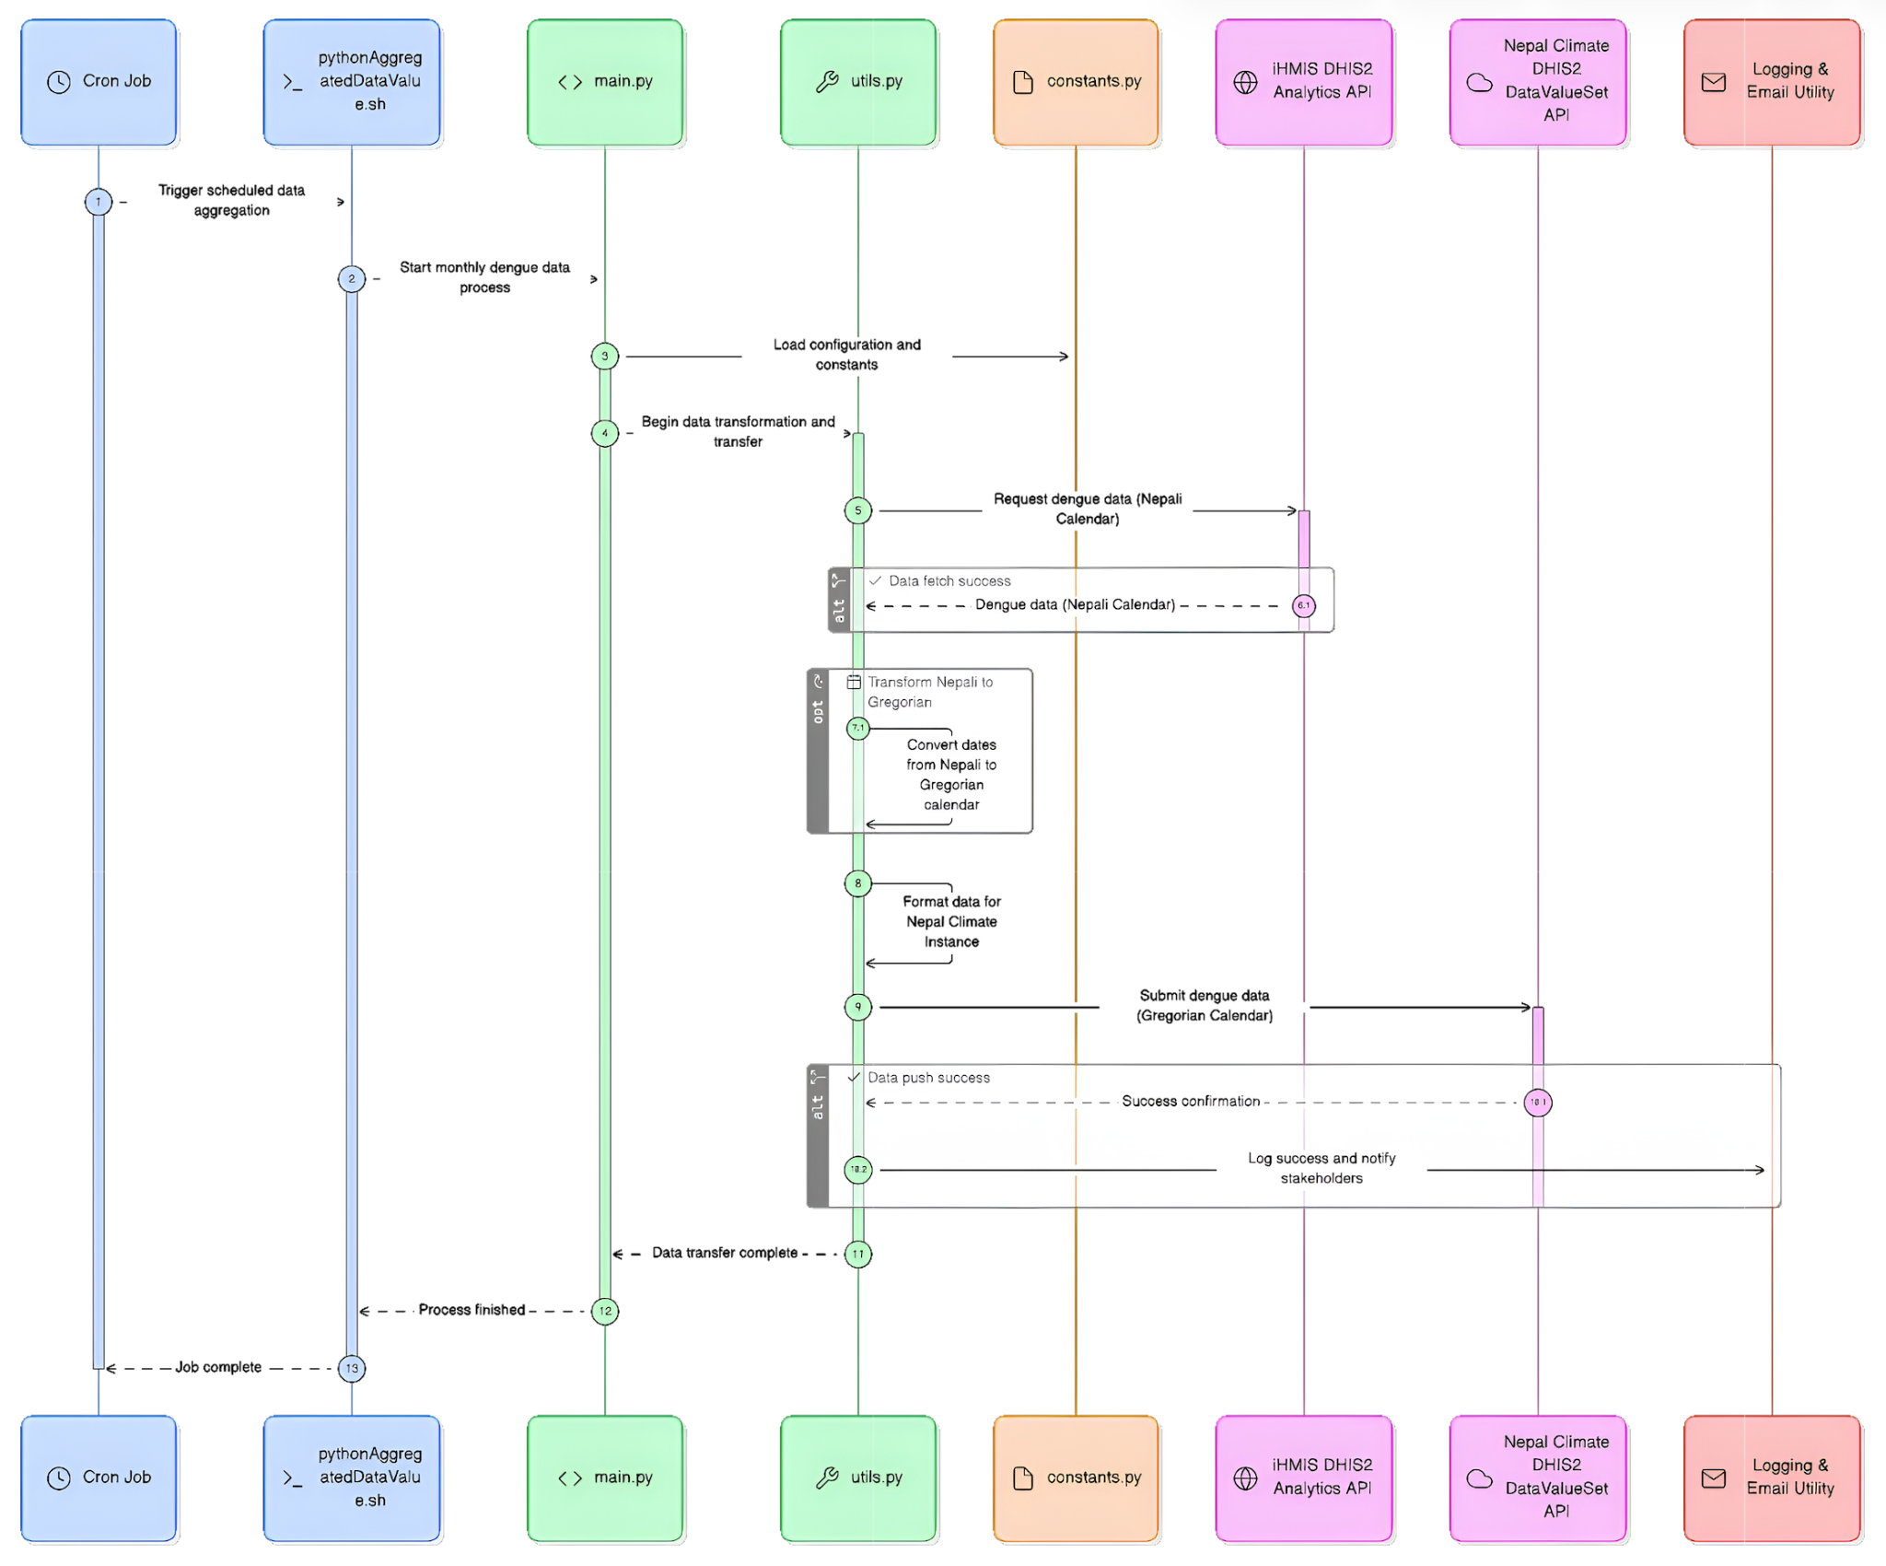

3. Workflow Description
This workflow describes an automated, scheduled process for aggregating dengue surveillance data, transforming it across calendar systems, and synchronizing it between two DHIS2 instances, the iHMIS DHIS2 and Nepal Climate DHIS2.

3.1 Job Scheduling and Triggering
The process is initiated by a Cron Job, which is configured to run on a predefined schedule (daily as of now). This ensures that dengue data aggregation and transfer occurs automatically without manual intervention. Once triggered, the Cron Job invokes the Python-based aggregation script (pythonAggregatedDataValues.sh), which acts as the entry point for the workflow execution.

3.2 Workflow Initialization
The shell script launches the main Python application (main.py), which orchestrates the end-to-end workflow. During initialization:
- Configuration parameters, credentials, and system-level constants are loaded from constants.py.
- Shared helper functions for data transformation, date conversion, API handling, and validation are loaded from utils.py.

3.3 Data Extraction from iHMIS DHIS2
The workflow begins the data processing phase by requesting monthly dengue data from the iHMIS DHIS2 Analytics API, the steps are given below:
- Data is retrieved using the Nepali calendar, which is the source system’s reporting standard.
- The request fetches aggregated dengue data required for climate and health data analysis.
- Successful data retrieval is explicitly checked and acknowledged before proceeding.

3.4 Calendar Transformation (Nepali to Gregorian)
Since the Nepal Climate DHIS2 instance operates on the Gregorian calendar, the extracted data undergoes a transformation step:
- Reporting periods are converted from the Nepali calendar to the Gregorian calendar.
- This transformation is handled within utils.py, ensuring consistent and validated date mapping.
- The transformed data preserves data integrity while aligning time periods with the Gregorian AD calendar months in Climate and Health instance.

3.5 Data Formatting for Target Instance
After calendar conversion, the dengue data is reformatted to match the Nepal Climate DHIS2 data model, including:
- Proper structuring of data values
- Alignment with target data element and category option combinations
- Validation against expected payload structures for the DHIS2 Data Value Set API

3.6 Data Submission to Nepal Climate DHIS2
The formatted dengue dataset is then submitted to the Nepal Climate DHIS2 DataValueSet API using Gregorian calendar periods.
- The system waits for and verifies the API response.
- Successful data push is confirmed before moving to closure activities.
- Any failures at this stage can be logged and flagged for review.

3.7 Logging, Confirmation, and Notification
Upon successful data submission:
- The system records execution status, timestamps, and outcomes using the Logging Utility.
- A success notification can be triggered via the Email Utility to inform relevant stakeholders of successful completion.

3.8 Workflow Completion
After logging and notifications are completed:
- main.py signals that the data transfer process is complete.
- Control returns to the shell script, post which the Cron Job marks the execution as finished.

